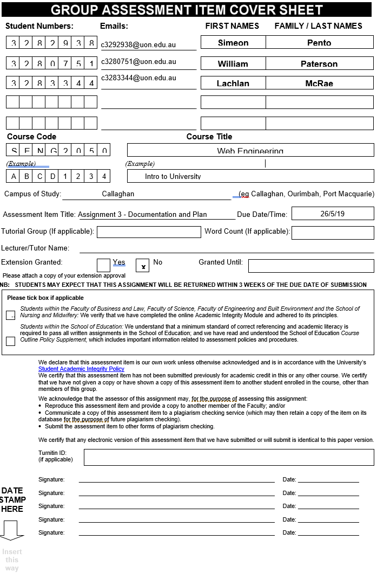

**SENG2050 – Assessment 3 – Documentation and Plan**

Authors: Simeon Pento (c3282938), William Paterson (c3280751) & Lachlan McRae (c3283344)

**Use Case Descriptions:** William Paterson

|  |  |
| --- | --- |
| **Login** | |
| MAIN ACTORS: | * *Users* * *Staff* |
| SECONDARY ACTORS: | * *System* |
| DESCRIPTION: | The *Actor* is logged into the *System* |
| BASIC FLOW: | 1. *Actor* enters username and password 2. *Actor* clicks login 3. *System* authenticates login information 4. *Actor* is redirected to main page |
| ALTERNATIVE FLOW: | 4a. *System* determines if *Actor* is *Staff*   * *System* sets User Type as staff member   4b. *System* fails to authenticate *Actor*   * *Actor* is informed login information is wrong * Login page is reloaded |
| PRE-CONDITION | * Page is loaded |
| POST-CONDITION | * *Actor* is logged in |

|  |  |
| --- | --- |
| **View Specific Report** | |
| MAIN ACTORS: | * *Users* * *Staff* |
| SECONDARY ACTORS: | * *System* |
| DESCRIPTION: | A specific report is displayed |
| BASIC FLOW: | 1. *Actor* selects report 2. *System* finds report 3. Report is displayed to *Actor* |
| ALTERNATIVE FLOW: | 2a. No report exists   * *System* informs *Actor* of error * *Actor* is redirected to main page |
| PRE-CONDITION | * Page is loaded * *Actor* is logged in |
| POST-CONDITION | * A specific report is displayed |

|  |  |
| --- | --- |
| **View Open Reports** | |
| MAIN ACTORS: | * *Users* * *Staff* |
| SECONDARY ACTORS: | * *System* |
| DESCRIPTION: | Any open reports are displayed |
| BASIC FLOW: | 1. *System* retrieves open reports 2. Reports are displayed to *Actor* in a table |
| ALTERNATIVE FLOW: | 1a. No reports exist   * *System* informs *Actor* no reports exist |
| PRE-CONDITION | * Page is loaded * *Actor* is logged in |
| POST-CONDITION | * Open Reports are shown |

|  |  |
| --- | --- |
| **View Knowledge Base** | |
| MAIN ACTORS: | * *Users* * *Staff* |
| SECONDARY ACTORS: | * *System* |
| DESCRIPTION: | All Completed reports are displayed |
| BASIC FLOW: | 1. *System* retrieves completed reports 2. Reports are displayed to *Actor* in a table |
| ALTERNATIVE FLOW: | 1a. No reports exist   * *System* informs *Actor* no reports exist |
| PRE-CONDITION | * Page is loaded * *Actor* is logged in |
| POST-CONDITION | * Completed Reports are shown |

|  |  |
| --- | --- |
| **Add Comment** | |
| MAIN ACTORS: | * *Users* * *Staff* |
| SECONDARY ACTORS: | * *System* |
| DESCRIPTION: | Allows actors to add comments to reports |
| BASIC FLOW: | 1. *Actor* selects report 2. *Actor* clicks on add comment 3. *System* redirect to add comment page 4. *Actor* enters comment details 5. *Actor* clicks submit 6. *System* add comment to report database 7. *Actor* is redirected to main page |
| ALTERNATIVE FLOW: | 1a. No report exists   * *System* informs *Actor* of error * *Actor* is redirected to main page |
| PRE-CONDITION | * Page is loaded * *Actor* is logged in |
| POST-CONDITION | * A comment is added to a specific report |

|  |  |
| --- | --- |
| **Mark Error Report as Completed** | |
| MAIN ACTORS: | * *Staff* |
| SECONDARY ACTORS: | * *System* |
| DESCRIPTION: | A specific report is marked as completed |
| BASIC FLOW: | 1. *Actor* selects report 2. *Actor* marks report as completed 3. *System* updates report status 4. *Actor* is redirected to main page |
| ALTERNATIVE FLOW: | 1a. No report exists   * *System* informs *Actor* of error * *Actor* is redirected to main page |
| PRE-CONDITION | * Page is loaded * *Actor* is logged in |
| POST-CONDITION | * A specific report is marked as completed |

|  |  |
| --- | --- |
| **Accept Marked as Completed Error Report** | |
| MAIN ACTORS: | * *Users* |
| SECONDARY ACTORS: | * *System* |
| DESCRIPTION: | Actor can accept or deny error completion |
| BASIC FLOW: | 1. *Actor* selects report 2. *System* informs *Actor* report has been marked as completed 3. *Actor* can then click accept or deny 4. *System* updates status of report 5. *Actor* will be redirected to main page |
| ALTERNATIVE FLOW: | 1a. No report exists   * *System* informs *Actor* of error * *Actor* is redirected to main page |
| PRE-CONDITION | * Page is loaded * *Actor* is logged in |
| POST-CONDITION | * Error report is accepted or denied |

|  |  |
| --- | --- |
| **Add to Knowledge Base** | |
| MAIN ACTORS: | * *Staff* |
| SECONDARY ACTORS: | * *System* |
| DESCRIPTION: | Add a completed report to the knowledge base |
| BASIC FLOW: | 1. Actor opens completed report 2. Actor clicks to add to Knowledge Base 3. System informs Actor report was added 4. Actor is redirected to main page |
| ALTERNATIVE FLOW: | 3a. Actor clicks do not add to Knowledge Base   * Actor is redirected to main page |
| PRE-CONDITION | * Report is marked as completed * Page is loaded * *Actor* is logged in |
| POST-CONDITION | * A report is added to Knowledge base |

|  |  |
| --- | --- |
| **Submit New Error Report** | |
| MAIN ACTORS: | * *Users* |
| SECONDARY ACTORS: | * *System* |
| DESCRIPTION: | A new error report is submitted |
| BASIC FLOW: | 1. *Actor* is asked to enter details of error 2. *Actor* clicks submit 3. *System* validates details 4. Entered details are entered into the database by the *System* 5. *System* informs *Actor* details were successful entered 6. *Actor* is redirected back to main page |
| ALTERNATIVE FLOW: | 2a. *Actor* clicks clear   * All entered details are cleared * Page is reloaded   3a. Details are invalid   * *System* informs *Actor* of error * *Actor* is redirected to main page   4a. *Actor* attaches a file   * *System* stores the file   5a. Error adding details to database   * *System* informs *Actor* of error * *Actor* is redirected to main page |
| PRE-CONDITION | * Page is loaded * *Actor* is logged in |
| POST-CONDITION | * A new report is submitted |

|  |  |
| --- | --- |
| **Edit Error Report** | |
| MAIN ACTORS: | * *Users* |
| SECONDARY ACTORS: | * *System* |
| DESCRIPTION: | Allows Actors to edit reports |
| BASIC FLOW: | 1. Actor edits details 2. Actors clicks submit 3. System validates details are |
| ALTERNATIVE FLOW: | 2a. No report exists   * *System* informs *Actor* of error * *Actor* is redirected to main page |
| PRE-CONDITION | * Page is loaded * *Actor* is logged in |
| POST-CONDITION | * A specific report is edited |

**Use Case Diagram:** William Paterson

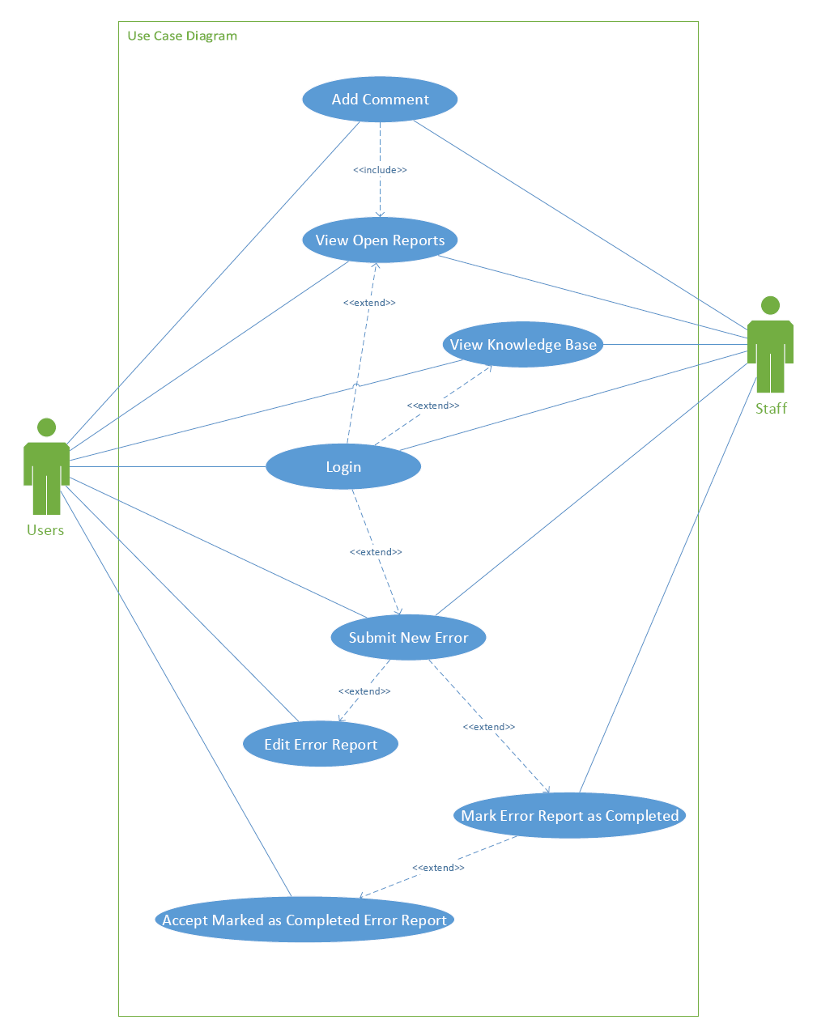

**Navigation Models:** Lachlan McRae

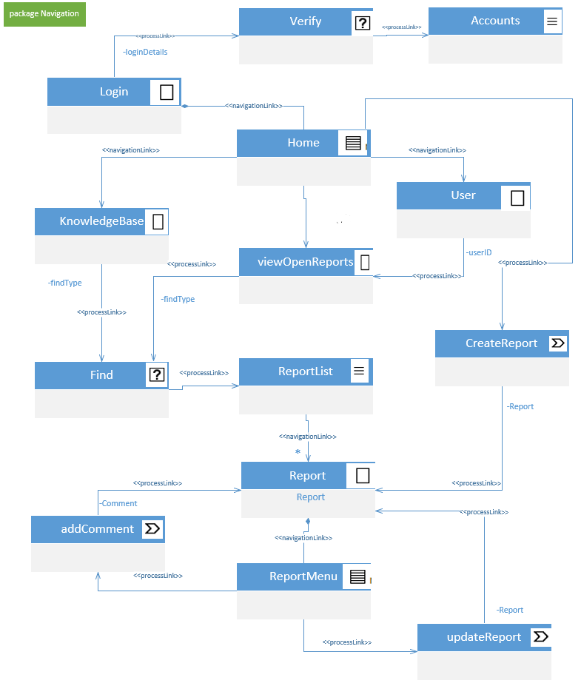

**Presentation Models:** Lachlan McRae

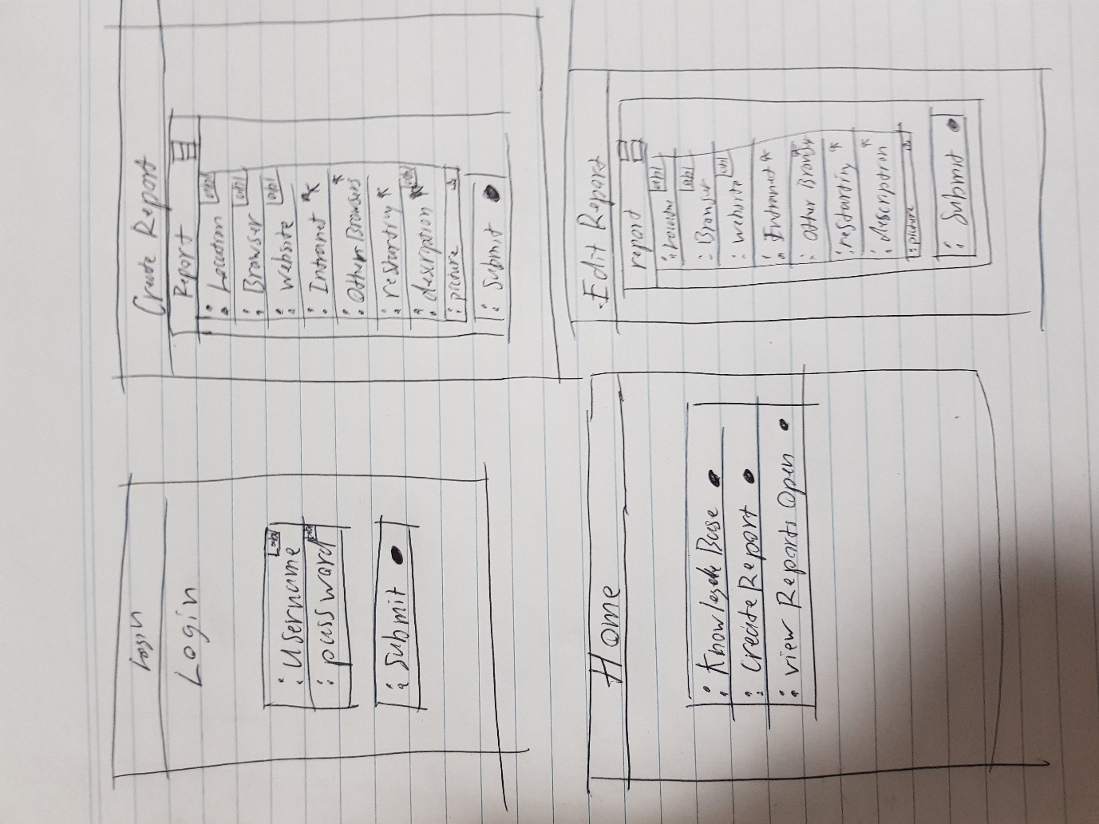

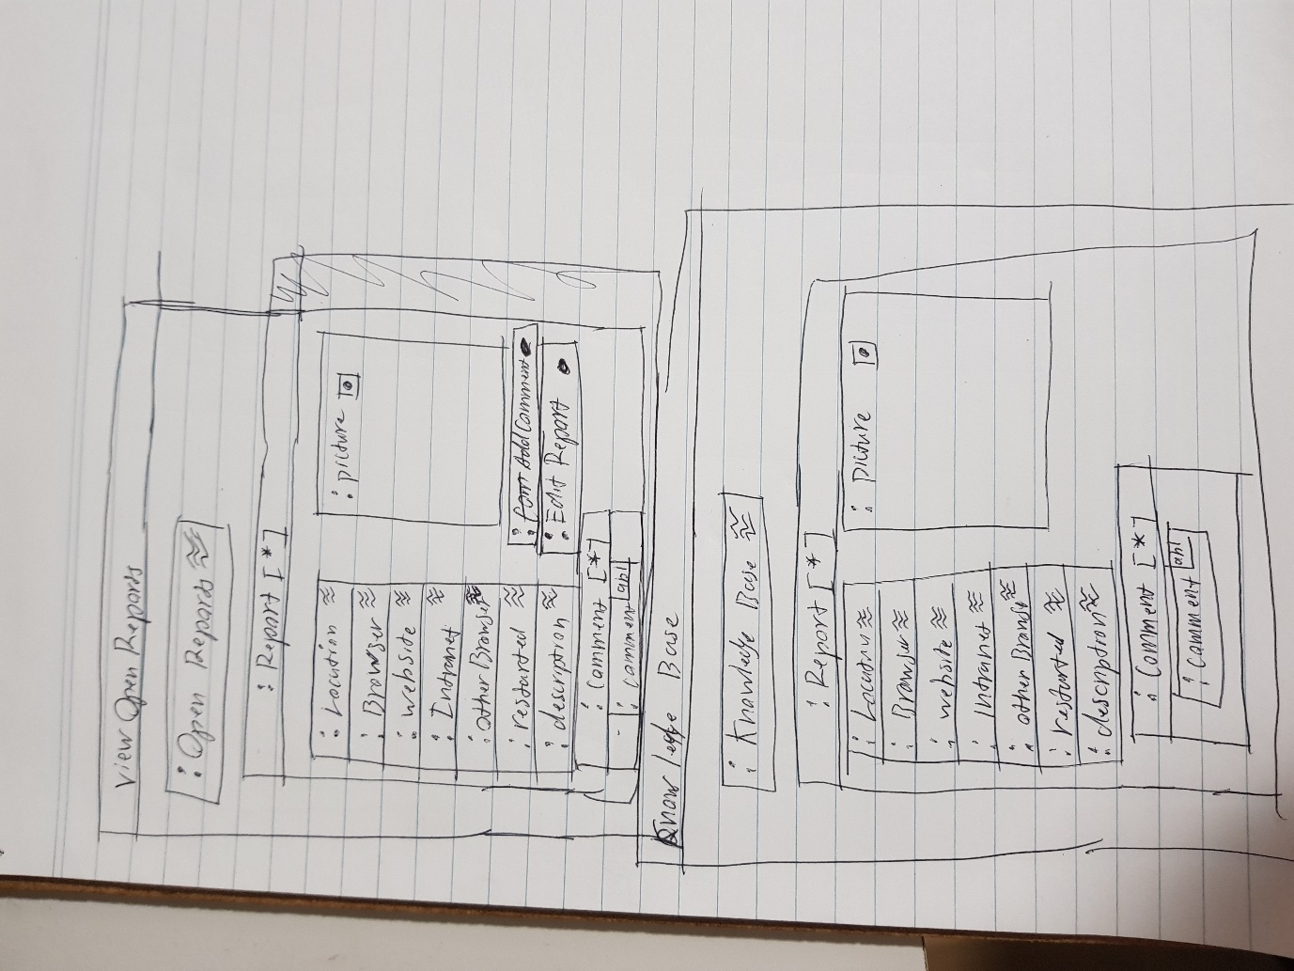

**Content Model:** Simeon Pento

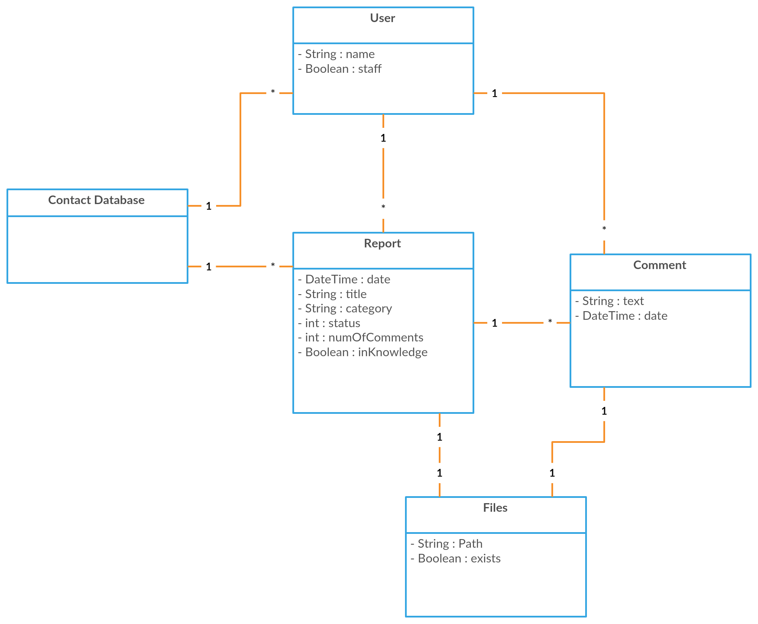

**Development Plan:** Simeon Pento

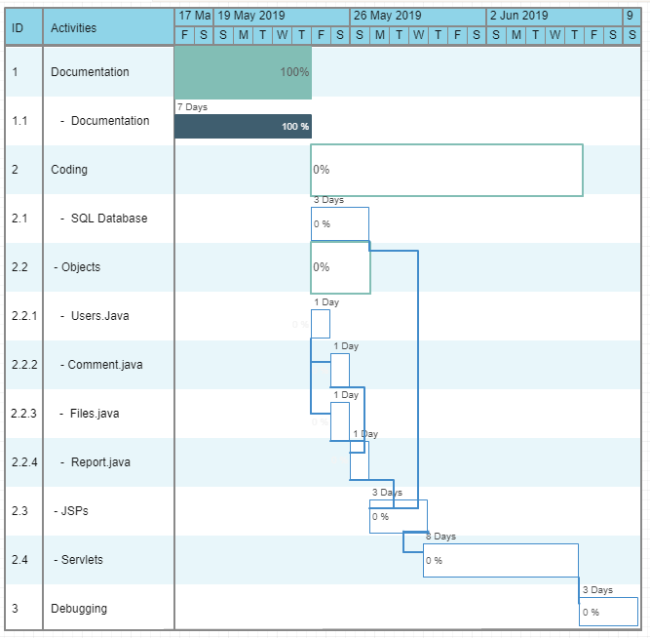

**Project Breakdown:**

* William:
  + SQL Database
  + Servlets
* Simeon:
  + Java Beans / Objects
  + JSPs
  + Servlets
* Lachlan
  + Servlets
  + Final debugging